CONSTRUCTION SPECIFICATIONS

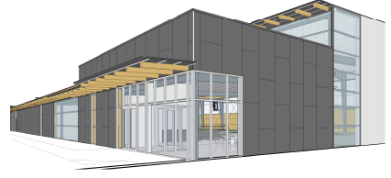

XCEL SPORTS COMPLEX
JEFFERSON, WISCONSIN

AUGUST 14, 2015

DRAFT ISSUE

